
What we do today, matters tomorrow.

Stokes Wood Primary School

Attendance Policy

This policy should be read in conjunction with the following policies:
- Child protection and safeguarding policy
- Behaviour policy
- SEND policy
- Exclusions/Suspensions policy

Approved by: | [Name] | Date: [Date]
Last reviewed on: | October 2023
Next review due by: | October 2024

Contents
1. Aims 2
2. Legislation and Guidance 3
3. How we Promote a Culture of High Expectations in Attendance and Punctuality 3
4. Roles and Responsibilities 3
5. Recording Attendance 5
6. Authorised and Unauthorised Absence 8
7. How we Monitor Attendance 9
8. Monitroring Arrangements 11
Appendix 1: Attendance Codes …………………………………………………………………………………………………………..12
Appendix 2: Applications for Leave of Absence Guidelines …………………………………………………………………14
Appendix 3: Circumstances for Issuing a Penalty Notice …………………………………………………………………….15
Appendix 4: Traveller Pupil Tracking Form ……………………………………………………………………………………….. 16
Appendix 5: Attendance Letters ………………………………………………………………………………………………………….18

1. Aims
Stokes Wood Primary School is committed to providing an education of the highest quality for all its pupils and recognises this can only be achieved by supporting and promoting excellent school attendance for all. Therefore, ensuring all pupils have high attendance is a key priority of ours.
Pupils are entitled to a full-time education, and we know that pupils with good attendance do better at school than those with high absence rates. We also know that absence can be a sign of other risks in a young person’s life.
The aim of this document is to set out how we create and maintain a positive culture that supports and values good attendance. It includes how we:
-Promote good attendance and punctuality
- Follow up absences - Communicate and work with families to reduce absence
- Monitor absences and analyse patterns of absence
- Work with local partners to support high attendance and reduce absence

2. Legislation and guidance
This policy follows the DfE Working Together to Improve School Attendance guidance, and refers to the DfE’s statutory guidance on school attendance parental responsibility measures. These documents are drawn from the following legislation setting out the legal powers and duties that govern school attendance:
- Part 6 of The Education Act 1996
- Part 3 of The Education Act 2002
- Part 7 of The Education and Inspections Act 2006
- The Education (Pupil Registration) (England) Regulations 2006 (and 2010, 2011, 2013, 2016 amendments)
- The Education (Penalty Notices) (England) (Amendment) Regulations 2013
This policy also refers to the DfE’s guidance on the school census, which explains the persistent absence threshold. Our work on attendance is linked closely to our approaches to safeguarding and behaviour. Therefore this policy also meets the requirements of other DFE guidance ‘Children Missing in Education’ and ‘Keeping children safe in education.’

3. How we promote a culture of high expectations in attendance and punctuality
Stokes Wood Primary School aims to work together with parents and carers to ensure that all children achieve excellent levels of attendance and punctuality. The school’s current target for pupil attendance is 96%, which is high and reflects the importance of regular attendance. The school day begins at 8:50am and ends at 3:20pm. Regular attendance is important, not just because the law requires it but because it is the best way of ensuring that children make the most of the educational opportunities which are available to them. Good attendance is an essential and crucial prerequisite to effective learning.
We will always seek to work alongside parents to overcome any barriers to regular attendance. We will always be understanding of such issues as transport, family issues or other barriers which may impact attendance and work with families to support them to find solutions. This process will be bespoke and tailored to the specific needs of individual families.

4. Roles and responsibilities
We all have a responsibility for ensuring good school attendance and have important roles to play. The purpose of the policy is to clarify everyone’s part in this. At Stokes Wood we will ensure that:
- Pupils are registered accurately and efficiently.
- Attendance targets are set for individual pupils and the whole school.
- Attendance and punctuality data is regularly and robustly monitored and reviewed.
- Pupils with excellent attendance are rewarded.
4.1 Pupils
Pupils are expected to:
- Attend school regularly.
- Attend school on time.
- Attend school prepared for the day.
- Speak to an adult in school if they have any problems which may lead to absences.

4.2 Parents and Carers
Parents/carers are expected to:
- Ensure their child attends school everyday.
- Ensure their child arrives at school on time, properly dressed and with the right equipment for the day.
- Notify school each day of their child’s absence using the school’s phone number (0116 2875305), School email (office@stokeswood.leicester.sch.uk) or reporting to the school office.
- Provide the school with more than one emergency contact number for their child.
- Ensure that, where possible, appointments for their child are made outside of the school day.
- Not expect the school to automatically agree any requests for absence, and not condone unjustified absence from school.
4.3 Class teachers
Class teachers are responsible for recording attendance on a daily basis, using the correct codes and submitting this information to the school office no later than 9:00am for the morning session and 1.20pm for the afternoon session. Class teachers will regularly remind pupils of good attendance and the schools attendance initiatives (see Section 7).
4.4 School Admin Staff
School admin staff are expected to:
- Take calls from parents/ carers about absence on a day-to-day basis and record it on the school system.
- Send daily texts home when pupils have been registered as absence and no reason has been given.
- Inform the pastoral team of any pupils’ absence with no reason by 11am.
- Transfer calls from parents to the Pastoral Team in order to provide them with more detailed support on attendance.
- Not accept an explanation of absence from your child.
- Produce and circulate weekly reports of pupils with attendance below 95%.
- Produce and circulate half termly reports for SEND and Pupil Premium attendance figures.
- Sending out the policy to all parents and staff annually.
4.5 The Pastoral Team
The pastoral team are responsible for:
- Phoning parents/carers if a pupil is absent from school with no reason to ensure pupil is safe (see safeguarding policy).
- Conducting safe and well checks if a pupil has been absent for more than 2 days and no reason for the absence has been given.
- Conducting home visits as requested by parents/carers and/or external agencies.
- Being out on the school playground/at the school office at the beginning and end of the school day.

  - The SLT member responsible for Attendance
The attendance leader is responsible for:
- Monitoring attendance data across the school and at an individual pupil level weekly.
- Providing regular attendance reports to staff and sharing these with the Headteacher and the Senior Leadership Team.
- Devising specific strategies to address areas of poor attendance identified through data.
- Sending letters to parents/carers regarding attendance.
- Praise pupils who have improved their attendance and pupils with good attendance.
- Arranging calls and meetings with parents to discuss attendance issues.
- Delivering targeted intervention and support to pupils and families.
- Working with local partners to implement bespoke strategies to improve attendance for those children with persistent absence or severe absence.
- Working with the Education Welfare Officer to tackle persistent and severe absence.
- Working with local partners when formal procedures such as parental contracts, supervision orders and penalty notices are required.

At Stokes Wood our attendance officer is Megan Williams and can be contacted via the school office (0116 2875305).
  - The Headteacher
The Headteacher is responsible for developing and implementing the attendance policy. In addition, the Headteacher will:
- Monitor school-level absence data and reporting it to the Governing Body.
- Support staff with monitoring the attendance of individual pupils.
- Work with the Local Authority to issue fixed-penalty notices and pursue court action where necessary.
- Hold the attendance lead to account.

4.8 School governors
The school governors are responsible for monitoring attendance figures for the whole school on at least a termly basis.

5. Recording attendance
5.1 Attendance register
We complete an attendance register and place all pupils onto this register. Classroom teachers are responsible for completing the attendance registers.
We take our attendance register at the start of the first session of each school day and at the beginning of the afternoon session (after lunch). It will mark whether every pupil is:
- Present
- Attending an approved off-site educational activity
- Late
- Absent
- Unable to attend due to exceptional circumstances.
The office staff will complete the register using the prescribed DfE codes (See appendix 1). We keep a record of all authorised and unauthorised absence. We will keep every entry on the attendance register for 3 years after the date on which the entry was made.

5.2 When registration takes place.
Children should be in their classroom for 8:50am for registration. The register will be completed promptly at 8:55am for the morning session and 1:15pm for the afternoon session. A mark will be made during the registration period in respect of each child.
5.3 Unplanned absence
The pupil’s parent/carer must notify the school on the first day of an unplanned absence by 9:30am or as soon as practically possible. If the school has not been notified of an absence by 9.30 am, the school will telephone or text to be reassured that a child is safe with a responsible adult.
We will mark absence due to illness as authorised unless the school has a genuine concern about the authenticity of the illness or the pupil’s attendance percentage is significantly below 96%.
If the authenticity of the illness is in doubt, the school may ask the pupil’s parent/carer to provide medical evidence, such as a doctor’s note, prescription, appointment card or other appropriate form of evidence. We will not ask for medical evidence unnecessarily.
If the school is not satisfied about the authenticity of the illness, the absence will be recorded as unauthorised, and parents/carers will be notified of this in advance.
If no explanation about an absence is received by the school within 2 weeks, the absence will remain unauthorised.
5.4 Planned absence
Attending a medical or dental appointment will be counted as authorised if the pupil’s parent/carer notifies the school in advance of the appointment. Parents will be asked to provide evidence that they are taking their child out of school for a medical appointment. This is to ensure that the appointment can be authorised.
However, we encourage parents/carers to make medical and dental appointments out of school hours where possible. Where this is not possible, the pupil should be out of school for the minimum amount of time necessary.
Regulations state that if the school is not informed by parents of visits to the doctor, dentist, illness etc. then these absences can become unauthorised. It is therefore essential that any reasons for absence (even short absences) be given to the office and preferably via email.
The pupil’s parent/carer must also apply for other types of term-time absence as far in advance as possible of the requested absence. Section 6 explains which term-time absences the school can authorise.

5.5 Lateness and punctuality
Poor punctuality is not acceptable. If your child misses the start of the day, they miss learning and miss being given vital information for the day. Pupils arriving late disrupt lessons, it can be embarrassing for the child, and this can also further encourage absence.

A pupil who arrives late:
- Before the register has closed (9:00am) will be marked as late, using the appropriate code (L)
- After the register has closed (9:10am) will be marked as absent, using the appropriate code (U)

Pupils who arrive after the registers have closed, will receive a mark that shows them to be on site, but this will not count as a present mark, and it will mean they have an unauthorised absence. This absence will be unauthorised unless the school is satisfied that there is a legitimate reason for the pupil to be late.
For health and safety reasons it is important that the school knows who is in the building. Pupils arriving late should therefore report to the school office. It is important that all pupils arriving late follow this procedure. For the same reason, it is important that parents of pupils leaving the premises legitimately (e.g. for a medical appointment) or returning to school later in the day, inform the school office. The school office will record that the child has left the school site and will mark them back in when they return.

Lateness across the school will be monitored. Pupils who are regularly marked as late are identified. Parents
will be contacted by the Pastoral Team, who will work with families in partnership to support with barriers to
punctual attendance. A range of strategies may be implemented to support families in these cases, tailored to
the specific needs of the family.

A record is also kept in the school office of any children who are collected late at the end of the school day. The school day ends at 3:20pm. After 20 minutes a telephone call is made to parents/carers to determine if everything is ok and how quickly the child can be collected. In the event that a child is regularly late in being collected from school at the end of the school day, the pastoral team will contact parents to request a meeting to discuss the situation. It is a parent/carer’s responsibility to ensure that their children are collected promptly from school and is a responsibility which the school will actively promote.

5.6 Following up absence.
Where any child we expect to attend school does not attend, or stops attending, the school will ensure appropriate safeguarding action is taken where necessary. The school will follow these procedures:
- Call the pupil’s parent/carer on the morning of the first day of unexplained absence to ascertain the reason. If the school cannot reach any of the pupil’s emergency contacts, the school will leave a message where possible asking parents to contact the school. This may then be followed up with a further phone call, home visit, letter or referral to the EWO (Education Welfare Officer).
- Identify the correct attendance code to use and input it as soon as the reason for absence is ascertained – this will be no later than 5 working days after the session.
- Call the parent/carer on each day that the absence continues without explanation to ensure proper safeguarding action is taken where necessary. If absence continues, we will consider involving the education welfare officer or similar.

5.7 Reporting to parents
We will regularly inform parents where their child has good attendance as well as where there are concerns about their child’s attendance and absence levels. This may be via phone calls, attendance letters and home visits. Parents/carers may be invited to a meeting to discuss the reasons for absence and plans put in place to support improving the attendance of the pupil. If cases of persistent or severe absence the EWO may be involved which may result in parents being invited into school for a panel meeting.
Overall attendance is reported via parents’ evenings, newsletters and the annual written report to parents.

6. Authorised and unauthorised absence
By law, every half-day absence from school has to be classified by the school, as either authorised or unauthorised. This is why information about the reason for any absence is always required.

6.1 Approval for term absence
The headteacher will only grant a leave of absence to a pupil during term time if they consider there to be 'exceptional circumstances'. A leave of absence is granted at the headteacher’s discretion, including the length of time the pupil is authorised to be absent for.
Stokes Wood considers each request for term-time absence individually, taking into account the specific facts, circumstances and relevant context behind the request.
Any request should be submitted as soon as it is anticipated and, where possible, at least 7 days before the absence. The Headteacher should be notified of any planned absence via email or a face-to-face meeting. Evidence may be required to support any request for leave of absence. You will be informed whether the absence will be authorised or unauthorised via email so this can be added to your child’s attendance record.
Valid reasons for authorised absence include:
- Illness and medical/dental appointments (if evidence is provided).
- The pupil lives more than three miles and no suitable transport arrangements have been made by the Local Authority.
- Religious observance – where the day is exclusively set apart for religious observance by the religious body to which the pupil’s parents belong. In line with DfE guidance, for all religious observance, it is expected that only one day is to be authorised for each religious celebration and then only where it falls on a school day. Parents should request this absence from the Head teacher beforehand. If necessary, the school will seek advice from the parents’ religious body to confirm whether the day is set apart.
- Traveler pupils travelling for occupational purposes – this covers Roma, English and Welsh gypsies, Irish and Scottish travelers, showmen (fairground people) and circus people, bargees (occupational boat dwellers) and new travelers. Absence may be authorised only when a traveler family is known to be travelling for occupational purposes and has agreed this with the school, but it is not known whether the pupil is attending educational provision.

The school is very aware that issues of attendance are sometimes due to factors beyond the control of parents or carers, such as long-term illness or hospitalisation and the school is committed to working with parents to limit the impact of these events on the development of individual children. In certain circumstances, other agencies such as the school doctor / nurse may be called on to support the process.
Holidays should not be taken in term time as they damage progress and continuity of learning. We will not authorise any holidays. Leave of absence may be granted in very exceptional circumstances.

6.2 Legal Sanctions
Where all voluntary support options are unsuccessful or not appropriate (such as an unauthorised holiday in term time), the local authority can take forward legal intervention to formalise support and / or enforce attendance. This includes fines or a penalty notice including court action. The arrangements for these procedures are found on the Leicester City Council website and in Appendix 4.

7. How we monitor attendance
The Attendance Officer will monitor attendance trends on a regular basis and report to the Headteacher and Pastoral Team. Weekly reports are run from SIMS with all pupils and groups of pupils being monitored. Any pupils who fall below 96% attendance are closely monitored for patterns. These patterns are then followed up with children and/or parents.
Pupils who fall below 90% are classed as Persistent Absentees (PA pupils). These pupils are rigorously tracked, and a range of support measures are offered in order to overcome barriers for attendance. Pupils who fall below 50% are classed as Severely Absent and the Pastoral Team will be involved.

Monitoring attendance
Stokes Wood will:
- Monitor attendance and absence data weekly, half-termly, termly and yearly across the school and at an individual pupil level.
- Identify whether or not there are particular groups of children whose absences may be a cause for concern.
- If a pupil’s absence falls below 96%, the school will follow the monitoring arrangements listed below:
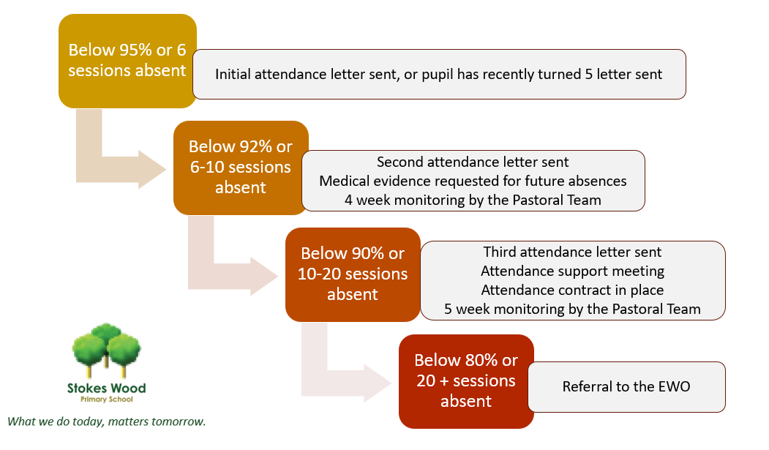

In addition, if a pupil’s final attendance fell below 96% for the last academic year, a letter is sent to parents at the start of the new academic year following an absence to remind them of the 96% target.
Pupil-level absence data will be collected each term by the DfE and published at national and local authority level through the DfE's school absence national statistics releases. The school will compare attendance data to the national average.

Analysing attendance
Stokes Wood will:
- Analyse attendance and absence data regularly to identify pupils or cohorts that need additional support with their attendance and use this analysis to provide targeted support to these pupils and their families.
- Look at historic and emerging patterns of attendance and absence, and then develop strategies to address these patterns.

Using data to improve attendance.
Stokes Wood will:
- Provide regular attendance reports to class teachers, and school leaders, to facilitate discussions with pupils and families.
- Use data to monitor and evaluate the impact of any interventions put in place to modify them and inform future strategies.

Reducing persistent and severe absence
Persistent absence is where a pupil misses 10% or more of school, and severe absence is where a pupil misses 50% or more of school. The school will:
- Use attendance data to find patterns and trends of persistent and severe absence.
- Hold regular meetings with the parents of pupils who we (and/or local authority) consider to be vulnerable, at risk of or persistently or severely absent, to discuss attendance and engagement at school.
- Provide access to wider support services to remove the barriers to attendance such as family support, Early Help and health professional referrals.

Promoting Positive Attendance
We have a range of rewards and celebrations around attendance to encourage pupils to attend school regularly. These include:
- Rewarding good attendance in assemblies for the class with the highest attendance and the most improved class attendance each week with an attendance trophy.
- Celebrate attendance percentages on the website and newsletters.
- Attendance Racetrack - the winning class at the end of each term receives a £30 prize.
- End of term certificates and badges for all children who have had 100% attendance during the term.
- Attendance improvement letters and stickers.
- Any child with 100% attendance for the term will be entered into the end of term draw for a £50 voucher. Children will be entered each time they are present all week.
- End of Year certificates/prizes for 100% attendance all year.
- A yearly attendance record for each child will be sent out with the statutory reports in July.

8. Monitoring arrangements
This policy will be reviewed as guidance from the DfE is updated, and as a minimum annually by the Attendance Lead or sooner if deemed necessary. At every review, the policy will be approved by the school governors.

Appendix 1: Attendance codes
The following codes are taken from the DfE’s guidance on school attendance.
Code | Definition | Scenario
/ | Present (am) | Pupil is present at morning registration
\ | Present (pm) | Pupil is present at afternoon registration
L | Late arrival | Pupil arrives late before register has closed
B | Off-site educational activity | Pupil is at a supervised off-site educational activity approved by the school
D | Dual registered | Pupil is attending a session at another setting where they are also registered
J | Interview | Pupil has an interview with a prospective employer/educational establishment
P | Sporting activity | Pupil is participating in a supervised sporting activity approved by the school
V | Educational trip or visit | Pupil is on an educational visit/trip organised, or approved, by the school
W | Work experience | Pupil is on a work experience placement

Code | Definition | Scenario
Authorised absence
C | Authorised leave of absence | Pupil has been granted a leave of absence due to exceptional circumstances
E | Excluded | Pupil has been excluded but no alternative provision has been made
H | Authorised holiday | Pupil has been allowed to go on holiday due to exceptional circumstances
I | Illness | School has been notified that a pupil will be absent due to illness
M | Medical/dental appointment | Pupil is at a medical or dental appointment
R | Religious observance | Pupil is taking part in a day of religious observance
S | Study leave | Year 11 pupil is on study leave during their public examinations
T | Gypsy, Roma and Traveller absence | Pupil from a Traveller community is travelling, as agreed with the school
Unauthorised absence
G | Unauthorised holiday | Pupil is on a holiday that was not approved by the school
N | Reason not provided | Pupil is absent for an unknown reason (this code should be amended when the reason emerges, or replaced with code O if no reason for absence has been provided after a reasonable amount of time)
O | Unauthorised absence | School is not satisfied with reason for pupil's absence
U | Arrival after registration | Pupil arrived at school after the register closed

Code | Definition | Scenario
X | Not required to be in school | Pupil of non-compulsory school age is not required to attend
Y | Unable to attend due to exceptional circumstances | School site is closed, there is disruption to travel as a result of a local/national emergency, or pupil is in custody
Z | Pupil not on admission register | Register set up but pupil has not yet joined the school
# | Planned school closure | Whole or partial school closure due to half-term/bank holiday/INSET day

Appendix 2: Applications for leave of absence guidelines.
Applications for leave of absence guidelines
Stokes Wood Primary School is very reluctant for a pupil to miss any part of their education.
- In line with the Government guidance, the school management and its governors are unable to authorise any term time absence, unless our view is that there are exceptional circumstances. Please note holidays taken in term time will NOT be authorised.

- If permission is granted, photocopies of airline or travel tickets will be required by the school office before you travel. If your request has been agreed, failure to provide this information will mean that the request is no longer agreed, and your child’s absence will be classed as unauthorised.

- We may also request copies of other travel related documents from you. We will advise you if this is the case. Where we do not receive copies of documents requested, this is likely to mean that we will not authorise some or all of any absence your child has in relation to this request.

- If permission is granted, pupils must ensure that they are up to date with their schoolwork before they leave and in addition, it will be parents’/carers’ responsibility to ensure that their son/daughter makes up any missed work in his/her own time upon return.

- The decision made by the school is final.

Please note
If your child has unauthorised leave of absence you will either be issued with a Penalty Notice of £120 per parent per child (discounted to £60 if paid within 21 days), or, your case will be referred by the Local Authority directly to the Magistrates’ Court.

Appendix 3 - Circumstances for Issuing a Penalty Notice

The Education Welfare Service will generally only consider it appropriate to issue a Penalty Notice if, following assessment, a parent is judged capable of but unwilling to secure the required improvement in their child's school attendance.

A Penalty Notice will be issued when either:

- A pupil has at least 20 unauthorised absences recorded against their name within the previous 120 school sessions (i.e., equivalent of 10 school days in any 12-school week period), or
- A pupil has leave of absence in term-time for which no permission has been sought from the school, or permission sought but refused, (that is unauthorised) or child has not returned by the agreed date (and no acceptable reason for delay has been received), or child has been encountered on more than one truancy patrol and the absences were unauthorised.

Unauthorised absence is where the school has either not received a reason for absence, or the reason given is unacceptable. It is the Headteacher who determines whether or not the absence is authorised. Head teachers are prohibited from granting leave of absence except where an application has been made in advance and they consider there are exceptional circumstances relating to the application.

Payment of Penalty Notices

The Education (Penalty Notices) (England) (Amendment) Regulations 2012 came into force on 1st September 2012.

The fine is £60 per parent/carer per child if paid within 21 days of issue, increasing to £120 if paid between 21 - 28 days.
The Local Authority states that parents who repeatedly take their children on holidays, trips etc. without the Headteacher's agreement will be taken directly to court and no Penalty Notice will be issued at the point of the 3rd unauthorised holiday for that child.
Where we have reason to believe a child was absent and had been away/on holiday etc, where this information is from a third party (e.g. from the child or other children in the class), we will write to parents to say that we understand the child was on holiday etc., and therefore, they may be issued with a Penalty Notice (per parent for each child) or, their case may be referred by the Local Authority directly to the Magistrates’ Court. (If parents don’t come back at this point to challenge the information and prove the child wasn’t taken away, the letter sent will be used in evidence in court.)

Appendix 4 – Traveler Pupil Tracking Form
The purpose of the form is to record the proposed leave of pupils from the travelling communities, recording details of their local residence and their current contact numbers. The purpose of the form is also to record information about intended travel dates and the expected date of return. If the family is staying on a Local Authority site in another area of the country, the details can be recorded and confirmed.
If the pupil is dual registered with a school outside of the local authority, this information should be confirmed, and the dual registration procedures undertaken accordingly.
The purpose of this process is to support good practice, to encourage traveler families to share their proposed arrangements prior to leaving and to ensure that effective contact is maintained. The Traveler Pupil Tracking Form should assist in reducing cases of children deemed to be missing in these circumstances and therefore strengthen the safeguarding procedures in place, as well as ensuring that children’s school attendance is maximised.
Together, we anticipate a continued improvement in attendance at school by working jointly with parent(s)/carer(s), specialist support from the Traveler Education Service and the Education Welfare Service to achieve better educational outcomes for our Traveler Children and Young People.
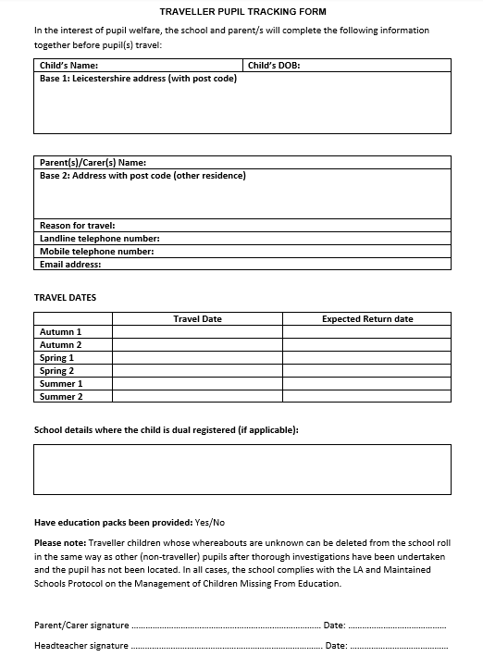

Appendix 5 – Attendance letters

