

Stokes Wood
Behaviour Policy

A consistent approach to behaviour management

This policy sets out to define a code of appropriate behaviour for Stokes Wood Primary School. The policy is based on the school’s vision of a safe, caring, thinking school and applies to every individual in the school.

Our school intends to encourage in pupils a sense of self-discipline and an acceptance of responsibility for their own actions.

We aim to create the conditions for an orderly and caring community in which effective learning can take place, where there is mutual respect for all members and a proper concern for the environment. All this will be done in the spirit of the school’s Mission Statement and consistent with other existing policies, e.g. Race Equality, Positive Handling, Equal Opportunities, Anti-Bullying and SEND. We consider every person to be of value, irrespective of age, disability, gender, sexual orientation, nationality, race, religion, status or socio-economic background.

Stokes Wood Primary School emphasises the importance of self-esteem and the positive reinforcement of good behaviour and realises that continuous poor behaviour from an individual may be the result of many other factors in the individual’s life, both in and out of school. When dealing with poor behaviour these factors will be taken into account as soon as they are realised and the positive aspects of the child’s behaviour will be built upon immediately.

Any sudden changes in a child’s behaviour pattern will also be investigated sensitively and acted upon in the same way in order not to make the situation worse.

At Stokes Wood Primary School:

- Every child has the right to feel safe, valued and happy within our school and free from any intimidation. There are NO OUTSIDERS at Stokes Wood Primary School.
- We will not tolerate any kind of anti-social behaviour, whether of a physical, mental or verbal nature, aimed at groups or an individual.

Our school’s beliefs about behaviour

- We believe in discipline and the need to foster in children a responsibility for their own behaviour. We ask parents to support us in these aims by promoting them through the newsletters, at parents’ meetings, Key Stage handbooks, website and outside screens.

- We believe that children need to develop a caring attitude towards each other.

- We believe children and staff should have good relationships which encourage mutual respect and this promotes good behaviour.

- We believe all staff should work together as a team and support one another in a ‘consistent’ positive approach to the way behaviour is promoted.

- Within our school we seek to promote the values of honesty, politeness, respect and care for others, self-discipline, tolerance and responsibility. We reject bullying, cheating, irresponsibility and dishonesty.

- We believe no-one has the right to prevent another child from learning or a teacher from teaching.

- We promote equality through the No Outsiders Project which teaches the whole community about respect for all including those with protected characteristics (there are numerous resources to support teaching and understanding of the importance of equality).

Aims and objectives of the Behaviour policy at Stokes Wood Primary School

Aim 1: To provide an environment which reflects the ethos of Stokes Wood Primary School.

Objectives

- We will encourage mutually respectful relationships among adults, among pupils and between adults and pupils, promoting self-esteem and pride in achievements.
- We will provide a setting which appears cared for and welcoming so that the adults and pupils can take pride in their surroundings and understand their value.
- We aim to increase the individual’s capacity to accept responsibility for actions taken.

Aim 2: To establish a code of conduct within a caring framework so that everyone feels safe, valued and happy.

Objectives

a) We will make frequent reference to rules, consequences and rewards as appropriate to the key stage procedures, after consultation with staff, pupils and parents, emphasising positive aspects rather than negative and emphasising consistency.
b) We will identify a system of praise and rewards for good behaviour.
c) We will establish a system for dealing with unacceptable behaviour.
- We will identify a system of sanctions.

Key Principles

- Fairness needs to be shown at all times.

- Rewards always outweigh sanctions.

- Rules are clear and consistent to all concerned and recorded in a user friendly manner.

- Recognition of equality for all members of the school community.

- Rules should be reinforced and everyone informed of policy changes as and when they arise.

- The rules should be made available to all interested parties, including staff, governors, parents, students, pupils and the wider community (website and school office).

- All staff are responsible for reminding children of the rules and consequences each term and whenever is necessary.

- Appropriate guidance is provided, showing how children should behave in all parts of the school. E.g. posters, assemblies, displays, role models.

- Policy and procedure on rules, rewards and sanctions should be communicated to parents, pupils, staff and governors on a regular basis.

We encourage all members of staff to praise in a number of ways  - A quiet word of encouragement  - A positive written comment on a piece of work  - Class Pom Pom/pasta Reward System or similar  - Pupil of the week certificate awarded in assembly  - Raffle tickets  - 6Rs Stickers and certificates  - A visit to another member of staff, or the Headteacher  - Praise in front of the group, class or whole school  - Acknowledgment by presentation of a special award at an assembly  - Given a special privilege  - Display of work  - Inviting parents/carers in to share good work  - A phone call home to share good news  - A Good to be Green card  - A letter home to parents / carers informing them of some action or achievement deserving praise  - Friendship Cups: annual awards  - Stickers are given with written comments or smiley faces in books and on uniform  - Good sitting in assembly stickers and certificates  - Good standing in line quietly stickers  - Lunchtime stickers for manners etc | The following actions have consequences  - Unacceptable behaviour  - Fighting or play fighting  - Pupils who are found to have made malicious accusations against school staff  - Breaking school rules  - Failing to follow instructions  - Not completing work to an expected standard  - Violence or threatening behaviour towards others  - Swearing  - Damaging property

Our Friday assemblies publicly recognise good behaviour. A weekly assembly takes place where parents and Governors are invited to see their children receive their awards.

When we do have to deal with unacceptable behaviour, all members of staff follow the outlined policy. We attempt to be constructive by giving advice on how to improve. The majority of pupils will respond to encouragement and a good reward system is essential for progress. It is hoped that by promoting positive behaviour and good work we will set the standards that we all wish to see throughout the school.

Every effort is made to ensure that there is good communication between home and school. Should a child’s behaviour be cause for concern (they have received a Target Card) their parents will be contacted and the matter discussed.

Our school is a community and children need to be taught as early as possible to appreciate that school is a workplace in which a certain code of behaviour has to be adhered to for the good of the whole community. We use an assertive discipline policy that is based on respect for all members of the school community. Stokes Wood Primary School staff support the following:

- Acceptable standards of behaviour depend on the example of all of us – everyone has a positive contribution to make.

- Good order has to be worked for, it does not simply happen.

- We set high standards, apply rules firmly and fairly and expect acceptable standards of behaviour and work.

- Everyone is here for a purpose and must be treated as an individual.

- Relationships are vital between everyone at every level.

- We all make mistakes sometimes and are willing to admit if we are wrong.

- Problems are normal where children are learning and testing the boundaries of acceptable behaviour.

All staff will always avoid:  - Humiliating – it breeds resentment  - Shouting – it diminishes you  - Over reacting – the problems grow  - Blanket punishments – the innocent will resent them  - Over punishment – never punish what you can’t prove  - Sarcasm  - Leaving pupils unaccompanied outside rooms | All staff will always:  - Keep calm  - Listen  - Be positive  - Build relationships  - Carry out any threats that have had to be made  - Be consistent  - Follow up problems to their conclusion  - Always apply school rules.

Rules for Children

Our school rules are:

- We keep our hands, feet and objects to ourselves

- We move safely around our school

- We listen to and follow instructions straight the way

- We respect our school and everyone in it

- We are always ready to learn

- We always do the kindest thing

Meetings and Incidents

Whilst the whole school will work very hard to develop positive attitudes to behaviour, there are occasions when sanctions have to be applied. It is the school policy to involve parents in the problem-solving process. It is hoped that by working together, we may foster in the pupil a desire for self-discipline.

As a matter of policy, the school records ‘incidents’ and causes for concern on CPOMS (web-based recording software). Please refer to Table of Behaviours which categorises types of incident. See Safeguarding and Child Protection Policy for guidance on causes for concern.

All possible racist incidents will be acknowledged and investigated as a matter of urgency. If racist behaviour has been confirmed, parents will be informed and the incident recorded on CPOMS.

Similarly, records are kept of ‘meetings’ with parents, the reason for calling them, the views expressed and any action taken. These factual records are available for inspection by the parents concerned.

Records are kept of all meetings and phone calls about behaviour or other concerns.

Please make sure a member of the Senior Leadership Team or pastoral team is aware of any serious incidents.

Problems in school fall mainly into two categories.

Learning Difficulties

These problems are dealt with in conjunction with the school’s pastoral team, SENDCo, class teacher, Headteacher, Educational Psychologist, Special Needs Teaching Service and Social, Emotional and Mental Health team (SEMH).

The school endeavours to keep parents fully informed and involved.

Behavioural Incidents

Most behavioural incidents are minor and are dealt with by the teaching staff. erious incidents are dealt by the Headteacher, Pastoral Team, Deputy Headteacher and Assistant Head Teachers. However, in more serious cases advice may be sought from the Educational Psychologist, SEMH team and Intervention Programmes e.g. Attention Deficit Hyperactivity Disorder (ADHD) Solutions. The support and active involvement of the parents is essential if these difficult problems are to be resolved.

If a particularly serious incident takes place, help from an additional member of staff (another teacher or the Headteacher) will be requested. The majority of the school team are ‘Team Teach’ trained and these members of staff will intervene in a situation where a pupil is committing an offence, injuring themselves or others, or damaging property. The power to use reasonable force also applies to maintain good order and discipline in the classroom. This is always a last resort. Please refer to the Stokes Wood Primary School Positive Handling Policy for more information.

It’s Good to be Green

Every class has a wall chart displaying each child’s name. Every morning each child has a fresh start and has their card on green.

Consequences
A child may be asked to stay in over a break or lunchtime to complete or redo work if it is not completed to an expected standard.

After an incident of inappropriate behaviour, teachers will try to discover the facts and who is involved in a given situation. They will then decide the appropriate action or strategy to be employed.

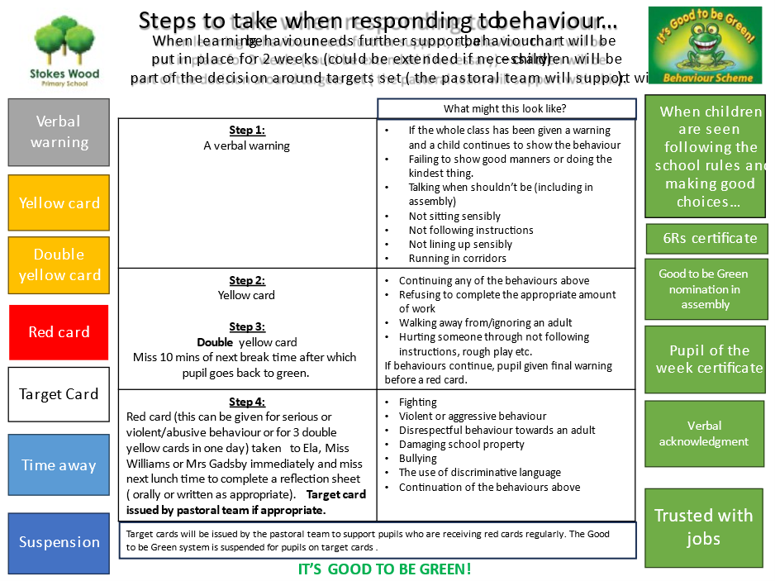

School trips

Where a school trip is arranged, children with an Individual Positive Behaviour Plan will have their attendance on the trip judged on a case by case basis. A full discussion will take place with the parent/carer, with a decision being made by the Headteacher, ensuring the best interests of the child and his/her peers being considered.

Any child with a Positive Behaviour Plan attending a school trip, will need an individual risk assessment, which is shared, agreed by the child’s parent. This should include clear procedures should the child need to return early from the trip due to disruptive or dangerous behaviour.

Racist/Bullying/Homophobic/Sexist Comments

Stokes Wood Primary School takes a no tolerance view to any form of discrimination. All incidents are recorded on CPOMS, reported and investigated according to the school’s policies.

Guidelines on Intervening in Fights/Disputes

Through the implementation of this policy, we expect fighting to be an extremely rare occurrence. However, if a child does lose his/her temper and become involved in a fight it will be taken extremely seriously. If a member of staff witnesses a fight they must remember:

- Our first duty is to prevent any harm to any pupil
- We need to set an example to pupils as to how to handle difficult situations
- To assess the severity of the situation
- To send a reliable child for additional help if necessary
- Verbally to move other children away
- Verbally separate the children involved – tell them to stop in an assertive voice
- Standing between the pupils may be appropriate to stop the fight
- It is school policy to intervene and physically prevent a pupil form hurting him / herself or anyone else (see the school’s Positive Handling Policy)
- Quiet discussion away from the scene will follow and the opportunity will be given for pupils to give their side of the story
- We will always listen to children.

If a pupil runs out of a class, we will establish where he or she has gone. Teachers must not run after them but will send a message to the office for adult support. An adult will observe any child who has taken him or herself out of the school building and out of school grounds, unless this provokes the child to run further. If a child is no longer on school premises parents will be contacted. The police will be informed that a pupil has left school and is at risk.

Clubs

The school’s behaviour system remains in place during any before or after school club. Should a child show continuous disruptive or abusive behaviour during the club, they will be banned from attending the remainder of the sessions. The leader of club will inform the parent/carer if this is the case.

Stokes Wood Playground and Astro-turf Rules

- These rules are for everyone.
- All pupils must follow all instructions and requests given by adults at the first time of asking.
- All pupils and adults are expected to be polite to each other.
- Bad language will not be tolerated on the playground or astro-turf. There is no tolerance in regards to swearing.
- Violence will not be tolerated on the playground or astro-turf.

Failure to follow the above rules will result in missing the rest of playtime and maybe the following playtime depending on the seriousness of the incident.
Lunchtime (See Happy Lunchtime Policy)

Lunchtime staff take ownership of sanctions and rewards: quiet word, amicable resolution; 2-minute time out and apology, then a 5-minute time out if needed. Child has to stay with adult during this time. More serious (bullying, violence) will be referred to the teacher.

However, the teacher must ensure that a pupil returned to a lunchtime supervisor has reflected on the incident. The lunchtime supervisor will talk to the pupil and decide when he/she can return to the lunchtime activities.

Rewards: catch pupils being good and give out stickers. Lunchtime supervisors will nominate pupils for a certificate each half term.

Behaviour that requires pupils to have to leave the playground.
Major physical contact: fights that involve adults to intervene to separate, physical contact leaving marking, bruising, bite marks (this also includes throwing physical objects)
Swearing: If an adult hears a child swearing deliberately and with malicious intent to be hurtful to others
Damage: to school property or environment that incurs cost, including large scale graffiti

Recording

Behavioural incidents and unacceptable behaviour will be logged by the class teacher, either during daily observations or if more serious, in the child's record or home/school book and on CPOMS. Any relevant comments by parents would also be recorded.

Further action will be taken if the behaviour is frequent and disruptive or dangerous to others. If appropriate the SEMH Team may be consulted.

This information MUST be passed on to the child’s next teacher.

Parents will be kept informed at all stages either verbally, by written communication or by a telephone call.

Team Meetings and Senior Leadership Team meetings are opportunities for discussing behavioural concerns.

Guidance will be given to support staff on behaviour management, through organised training sessions and regular "in-house" meetings. Newly appointed Teaching Assistants and Lunchtime Supervisors will receive an induction session on behaviour management and organisation.

Individual Educational Programmes

The class teacher together with the pastoral team, SENDCo and other relevant professionals will devise Pupil Education Plans/ Positive Behaviour Plans to include the areas to be targeted. These targets and the results will be monitored by the class teacher and the results included in the child's folder. Parents and pupils must be involved wherever possible in the review and setting of new targets.

The pastoral team and SENDCo should be consulted when support programmes are unsuccessful, with a view to consulting external agencies. Detailed class teacher records are essential for this stage.

Staff Appointments

The Governors’ appointment panel must be familiar with this policy and ask interviewees about their philosophy and their ability to manage behaviour.

Appendices

Target Card

Name: |  |  |  |  |  |  |  | Class: |  |  |  |  |  |  | Week: |  | 1 2 |  |  | Review: |  |  | 1 2
Targets |  | To complete all work for the session |  |  |  |  |  | To respect others and school property (including positive language) |  |  |  |  |  |  | To follow all instructions given |  |  |  |  |  |  |  | Signed by a member of the pastoral team at the end of the day:
Session |  | 1 | 2 | 3 | 4 | 5 | 6 | 1 | 2 |  | 3 | 4 | 5 | 6 | 1 | 2 |  | 3 | 4 |  | 5 | 6
Monday

Tuesday

Wednesday

Thursday

Friday

How the target card works:
A child on report must get each session signed by appropriate member of staff to say that they have passed the expected standard of behaviour.
The child can show their report card to a member of the pastoral team at the end of each session, and this must be signed by a member of the pastoral team at the end of each day.
A child is given three chances to achieve their target for each session with adults using scripted language:
- “......., first time of asking, please (given instruction)”
- “......., second time of asking, if I get to third time, (given instruction) your target for this session will not be signed.”
- “......., third time of asking, if you don’t (given instruction) your target for this session will not be signed”.
Example:
Rob, first time of asking, please sit down and begin your work.
Rob, 2nd time of asking and remember if I get to the 3rd time and you do not sit down and start your work, your card will not be signed.
Rob, 3rd time of asking. If you do not sit down and start your work now, your card will not be signed.
